ASSIGNMENT -4

Ques 01.Write a program to print sum of 10 numbers stored in an array.

**Code -**

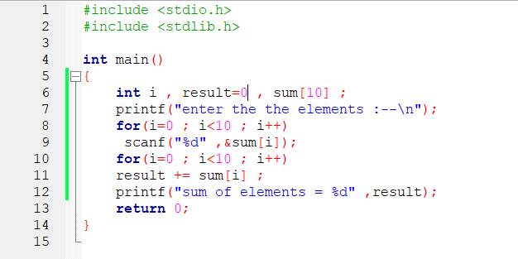

**output -**

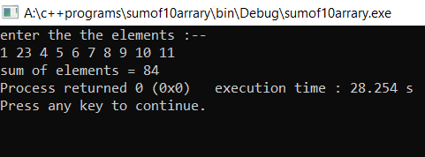

AKSHAR BISHT 1 BCA 1st YEAR 2ND SHIFT

Ques 02.WAP to find mean of five numbers using arrays.

**Code -**

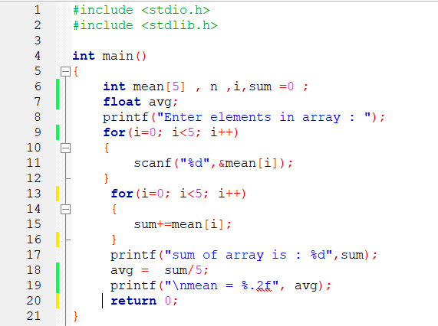

**output -**

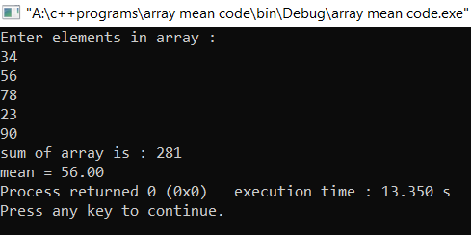

AKSHAR BISHT 2 BCA 1st YEAR 2ND SHIFT

Ques 03.WAP to read five values in an array and print them in reverse order.

**Code -**

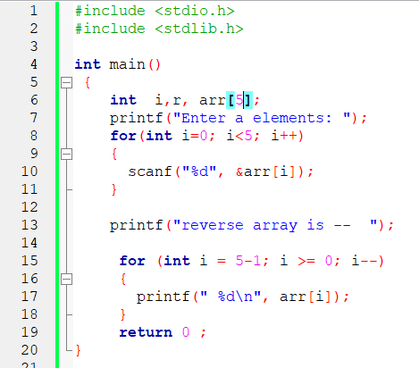

**output -**

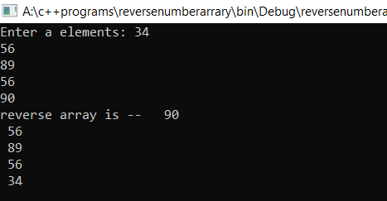

AKSHAR BISHT 3 BCA 1st YEAR 2ND SHIFT

Ques 04.WAP to read 5 values in an array and print the greatest and lowest value.

**Code -**

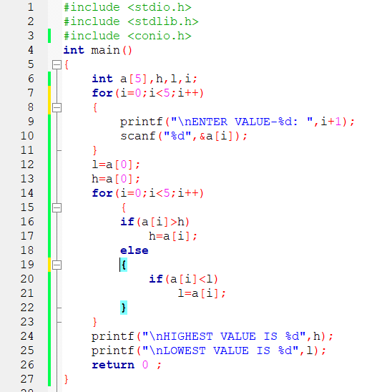

**output -**

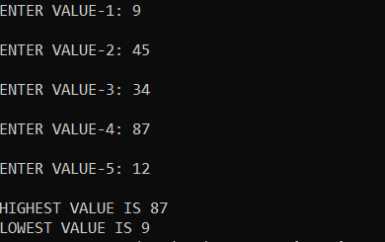

AKSHAR BISHT 4 BCA 1st YEAR 2ND SHIFT

Ques 05.WAP to accept 10 values in 2 arrays of size 5 each and concatenate them into 3rd array of size 10.

**Code -**

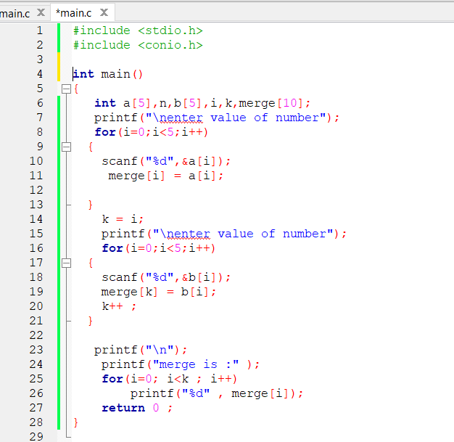

**output -**

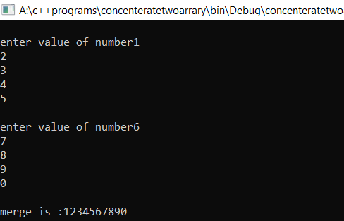

AKSHAR BISHT 5 BCA 1st YEAR 2ND SHIFT

Ques 06.WAP to find the sum of two 2-D arrays. Print the array in the matrix form.

**Code -**

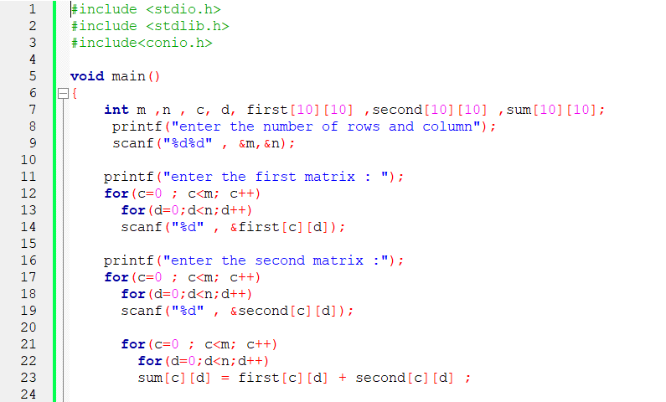

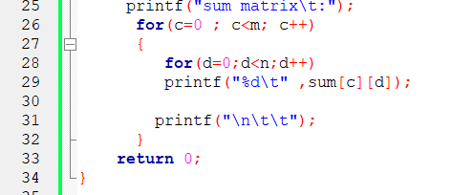

AKSHAR BISHT 6 BCA 1st YEAR 2ND SHIFT

**output -**

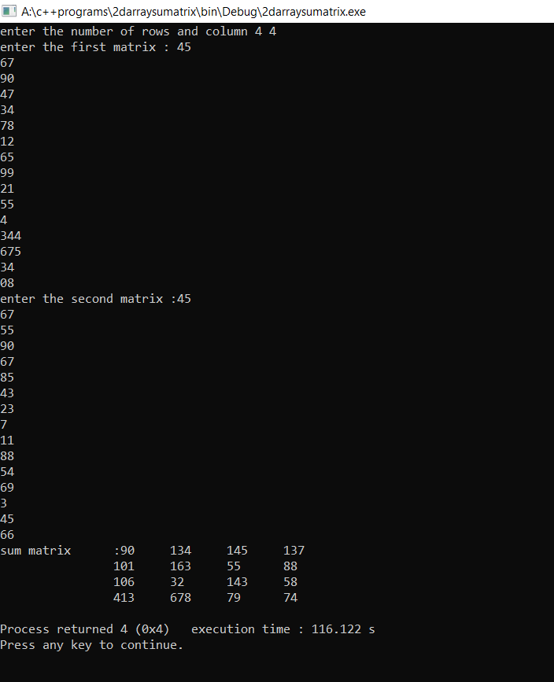

AKSHAR BISHT 7 BCA 1st YEAR 2ND SHIFT

Ques 07.WAP to find:

1. Row wise sum

**Code -**

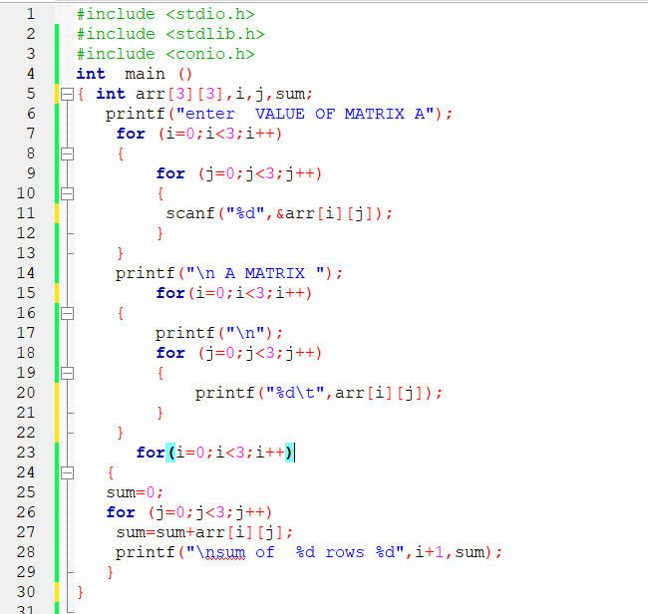

AKSHAR BISHT 8 BCA 1st YEAR 2ND SHIFT

**output -**

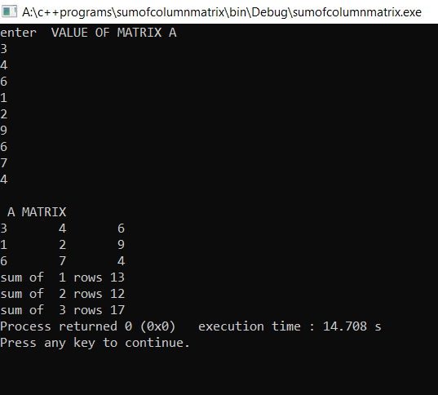

AKSHAR BISHT 9 BCA 1st YEAR 2ND SHIFT

1. Column wise sum

**Code -**

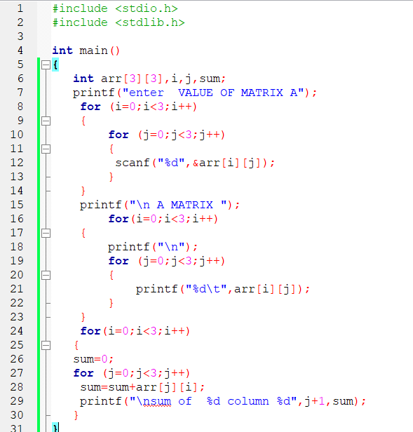

AKSHAR BISHT 10 BCA 1st YEAR 2ND SHIFT

**output -**

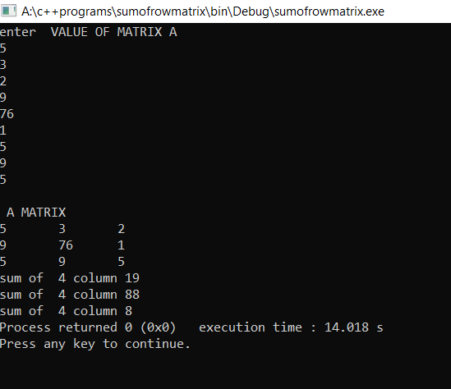

AKSHAR BISHT 11 BCA 1st YEAR 2ND SHIFT

c) Diagonal wise sum(both)

**Code -**

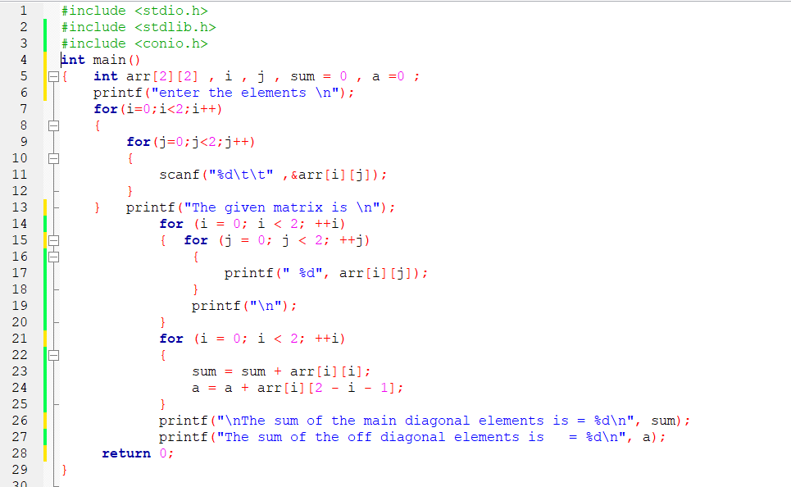

**output -**

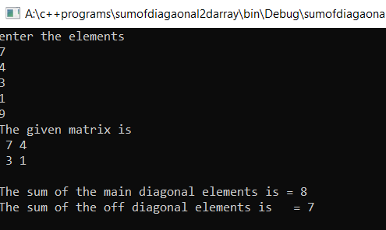

AKSHAR BISHT 12 BCA 1st YEAR 2ND SHIFT